**Lab Manual for**

**Artificial Intelligence**

Instructor: Abdul Hammad Rasheed

Lab # 07

Semester: Spring 2024

Department of AI & DS

National University of Computer and Emerging Sciences

Islamabad Campus

Carefully read the following instructions

1. Make a Jupyter Notebook file (.ipynb) with the convention “ROLLNO_NAME_SECTION_LABNO”

(E.g., 22I-1234_XYZ_BAI-A_01).

1. Write a code for each of the following tasks one after the other, in the same order.
2. At the end, when you are done with your lab tasks, make your submission on Google Classroom.

## LAB TASKS:

## Design and implement a robot navigation system where starting state and the goal state have been given which are basically the coordinates of the grid of size 15x15 as shown in Figure 1. For example, the start state has the coordinates is (1,2) and the goal state has the coordinates (15,14).

## Consider the following assumptions during the implementation of the robot navigation system:

## • The robot can only move,

## Up one cell with step cost 2,

## Right one cell with cost 2,

## Diagonally Up towards the right with cost 3.

## The robot cannot move downward one cell.

## The obstacles are color-coded, and the robot cannot be in those cells.

## Your task is to implement the following algorithms:

## Uniform cost search (UCS)

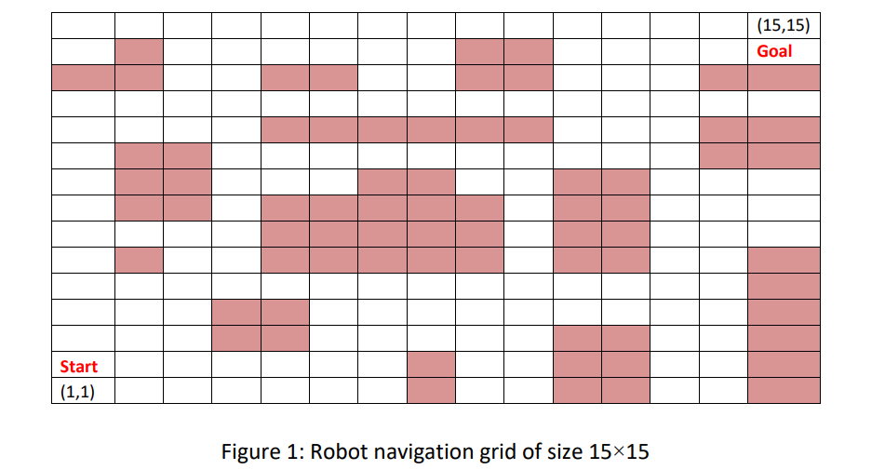

**Final Outputs**

Your designed system should output the followings:

1. The complete path as well as the traversal if the goal is reachable otherwise mention failure with some solid reasons.

2. The sequence of actions performed to reach the goal.

3. The total cost of the path.

4. A grid that shows the path followed. You do not need graphics for this output.

**Hints**

* The grid can be made textually using 1 for obstacles, 0 for empty cells (where the robot can move) and ‘*’ for path followed.
* For a heuristic-based search algorithm, you can use the Manhattan distance as a heuristic.